БЫЛО | СТАЛО
In person in Moscow | Убрать везде «in Moscow»
Online worldwide | Online
Online and In Person  We offer in-person appointments in Moscow and online sessions for clients in different countries. | Online and In Person  We offer in-person appointments and online sessions.
Articles by Ksenia Makarova and Svetlana Romanchenko for parents and adults who would like to better understand their concerns before getting in touch. | Articles by our psychologists for parents and adults who would like to better understand their concerns before getting in touch.
This section is led by two experts from the centre. New articles appear 2–4 times a month; discussion continues in the centre’s Telegram channel. | This section is led by our experts from the centre. New articles appear 2–4 times a month; discussion continues in the centre’s Telegram channel.
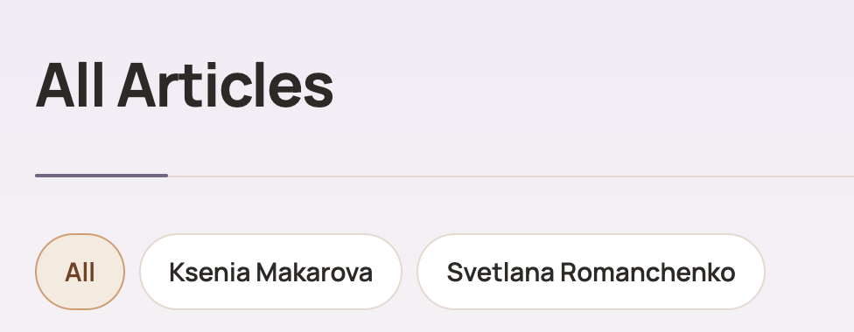 | Убрать плашки по специалистам
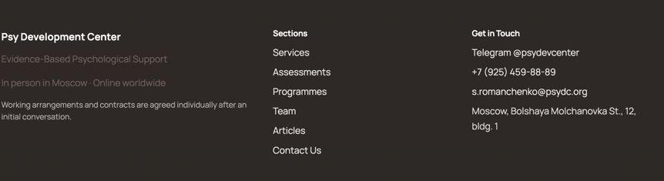 | Убрать телефон и адрес  почта: s.romanchenko@psydc.world
Team  Dr. Alex Desatnik | Dr. Alex Desatnik is a highly accomplished Clinical Psychologist, Consultant, and Senior Researcher based in London, UK. With over two decades of experience, he is recognized for his expertise in Mentalization-Based Therapy (MBT), adolescent mental health, and parent-child interventions. Dr. Desatnik bridges the gap between cutting-edge academic research and practical clinical application, working with families, educational institutions, and corporate organizations worldwide.  Professional Credentials & Affiliations  - Clinical Psychologist & Psychotherapist — Private practice and international clinical consulting.  - Senior Researcher & Academic — Collaborator with leading global institutions, including University College London (UCL) and the Anna Freud National Centre for Children and Families.  - Certified MBT Practitioner & Trainer — Specialist in Mentalization-Based Therapy for adolescents (MBT-A) and families (MBT-F) since 2008.  - Organizational Consultant & Executive Coach — Advisor to corporate leaders, applying psychological principles to team dynamics and leadership development.  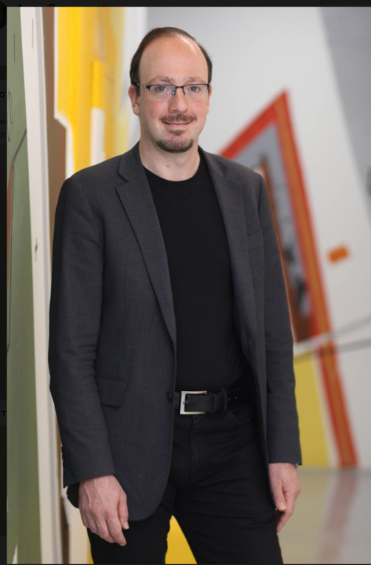
Team: Yulia Desiatnikova | Yulia Desiatnikova is a prominent practicing psychologist, international educational innovator, business consultant, and executive coach based in London, UK. With over 30 years of experience in premium education and applied psychology, she is widely recognized as the visionary founder of the London Gates Education Group and Russian Gymnasium №1. Yulia specializes in bridging deep psychological expertise with organizational growth, helping business owners and corporate leaders navigate complex management challenges, build high-performing teams, and optimize work-life balance.  Professional Credentials & Affiliations  - Founder & CEO, London Gates Education Group — Created a network of premium international educational centers operating globally, preparing students for admission to top-tier universities (including Oxford, Cambridge, Yale, and Stanford).  - Executive Coach & Business Consultant — Trusted advisor to top managers, entrepreneurs, and global leaders.  - Practicing Psychologist & Psychotherapist — Over three decades of counseling experience, specializing in systemic dynamics, family psychology, and individual growth.  - Educational Innovator — Co-founder of one of the first private schools in post-Soviet Moscow and a pioneer of language-immersion and creative educational frameworks for children internationally.  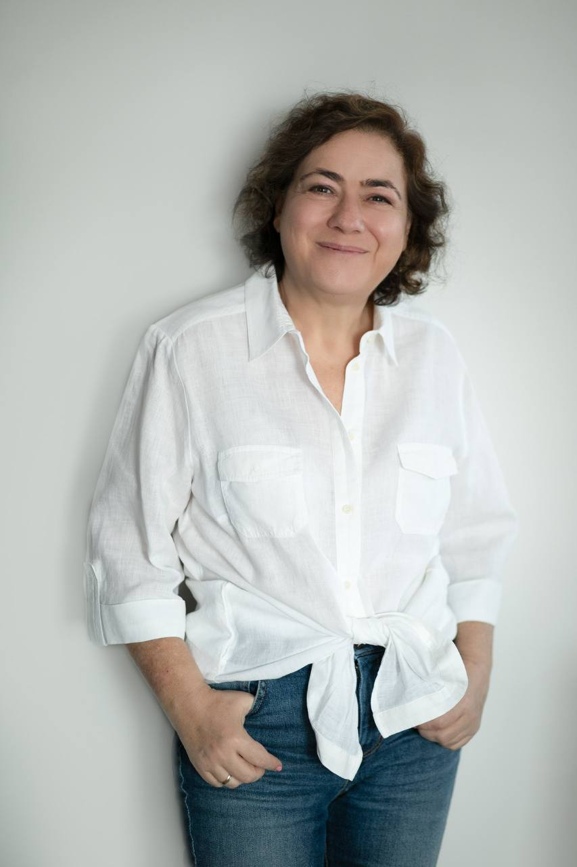
Team: Anna Malinovski | Anna Malinovski is a licensed Clinical Psychologist, CBT Practitioner, and Educational Mental Health Specialist based in Israel. With over a decade of comprehensive clinical experience, Anna specializes in psychological assessment, individual therapy, and evidence-based interventions for adolescents, young adults, and parents. Her practice integrates advanced cognitive-behavioral frameworks with systemic family dynamics to support clients navigating developmental milestones, emotional dysregulation, and interpersonal challenges. Known for her adaptive approach, Anna seamlessly bridges the gap between structured school-based mental health support and private clinical counseling.  Professional Credentials & Affiliations  - Licensed Clinical Psychologist — Officially registered and licensed by the Israeli Ministry of Health (Misrad HaBriut).  - CBT Psychotherapist — Certified practitioner utilizing Cognitive Behavioral Therapy as a core modality for treating anxiety and behavioral issues.  - Educational & School Psychologist — Resident practitioner specializing in school-based interventions, crisis support, and psycho-educational staff training.  - Parental Counselor & Group Facilitator — Expert in leading therapeutic workshops, parent support groups, and family systemic counseling.  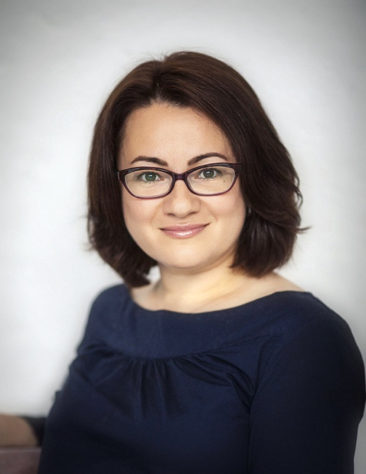
Team: Ksenia Makarova | Ksenia Makarova is an experienced Clinical Psychologist, CBT Practitioner, and Child Development Specialist based in Moscow. With over 13 years of clinical practice, she specializes in psychological counseling, cognitive-behavioral interventions, and emotional regulation for children, adolescents, and their families. Ksenia is widely recognized for her expertise in helping families navigate developmental crises, emotional burnout, anxiety, and neurodivergent challenges (including ADHD and ASD), establishing effective communication and mutual understanding between parents and youth.  Professional Credentials & Affiliations  - Clinical Psychologist & CBT Therapist — Expert in evidence-based individual and family psychotherapy.  - Child & Adolescent Mental Health Specialist — Focused on neurodevelopmental tracking, anxiety management, and coping mechanisms for youth.  - Parental Coach & Consultant — Facilitator of parent support groups, helping caregivers manage emotional burnout and systemic family crises.
Team: Svetlana Romanchenko | Svetlana Romanchenko is a dedicated Clinical Psychologist, DBT/CBT Practitioner, and Child and Adolescent Therapist based in Moscow. Specializing in neurodivergence, developmental psychology, and evidence-based psychotherapy, Svetlana works closely with clients aged 5 to 45, as well as their families. Her clinical practice focuses on helping individuals navigate complex emotional and behavioral challenges through highly individualized, compassionate, and structured cognitive-behavioral frameworks. Svetlana provides expert counseling fluently in both Russian and English.  Professional Credentials & Affiliations  - Clinical Psychologist & Child Psychotherapist — Practitioner specializing in developmental support, emotional regulation, and crisis intervention for youth.  - Certified DBT & CBT Therapist — Expert in Dialectical Behavior Therapy (DBT) and Cognitive Behavioral Therapy (CBT) for children, adolescents, and adults.  - Neurodivergence Specialist — Clinician focusing on support, social adaptation, and therapy for individuals with ASD (Autism Spectrum Disorder) and ADHD.  - Member of the Association of CBT Specialists

